**Amar Gajanan Mohite**

Section – IFT562

**Arizona State University**

Instructor**:** Daniel Wells

**Lab 7- Managing Resources**

Date – 03/10/2024

At the end of "Finding Development Instances For The Project" in Task 1, enter your full name in the command prompt, and take a screenshot.

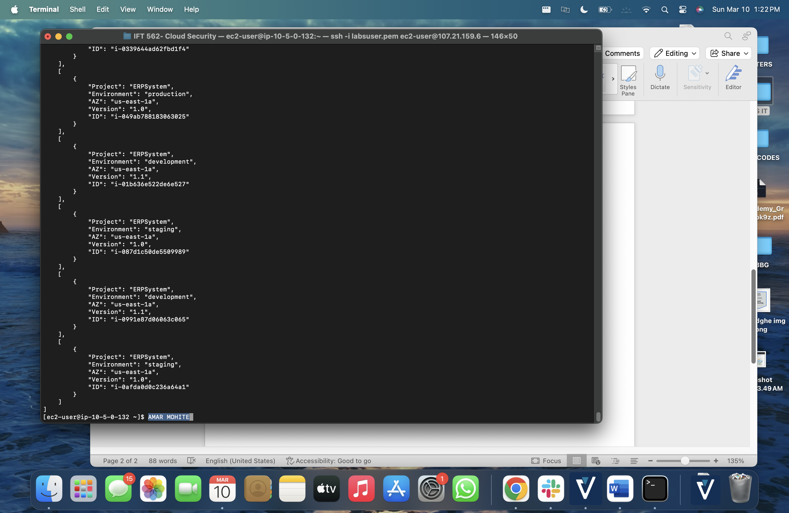

At the end of Task 2, after running the stopinator script enter your full name in the command prompt, and take a screenshot.

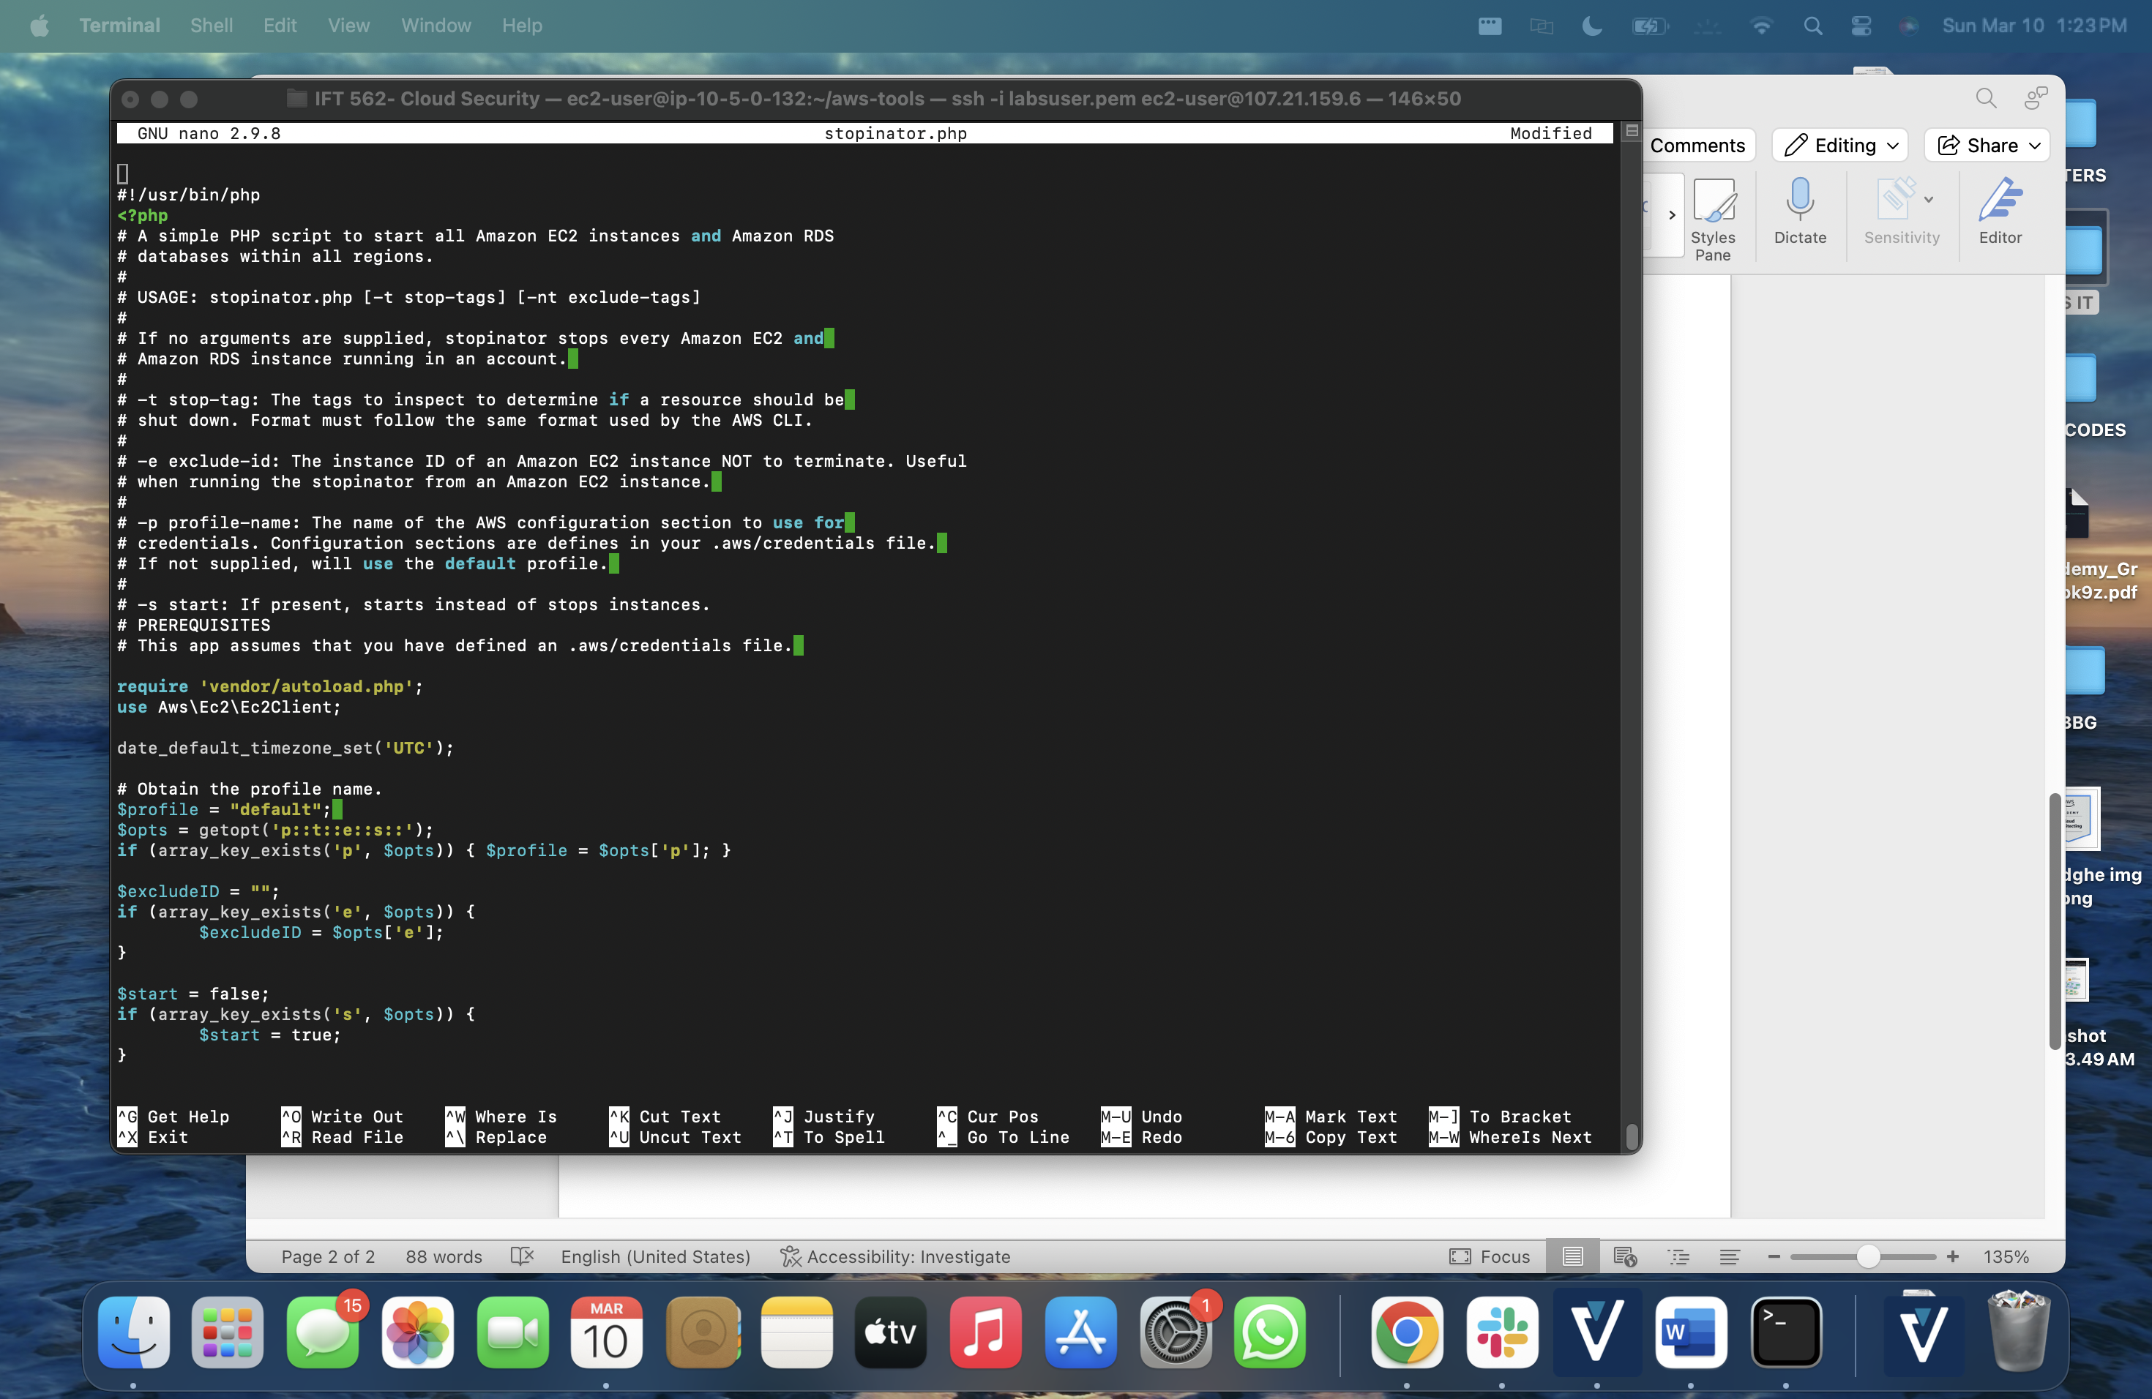

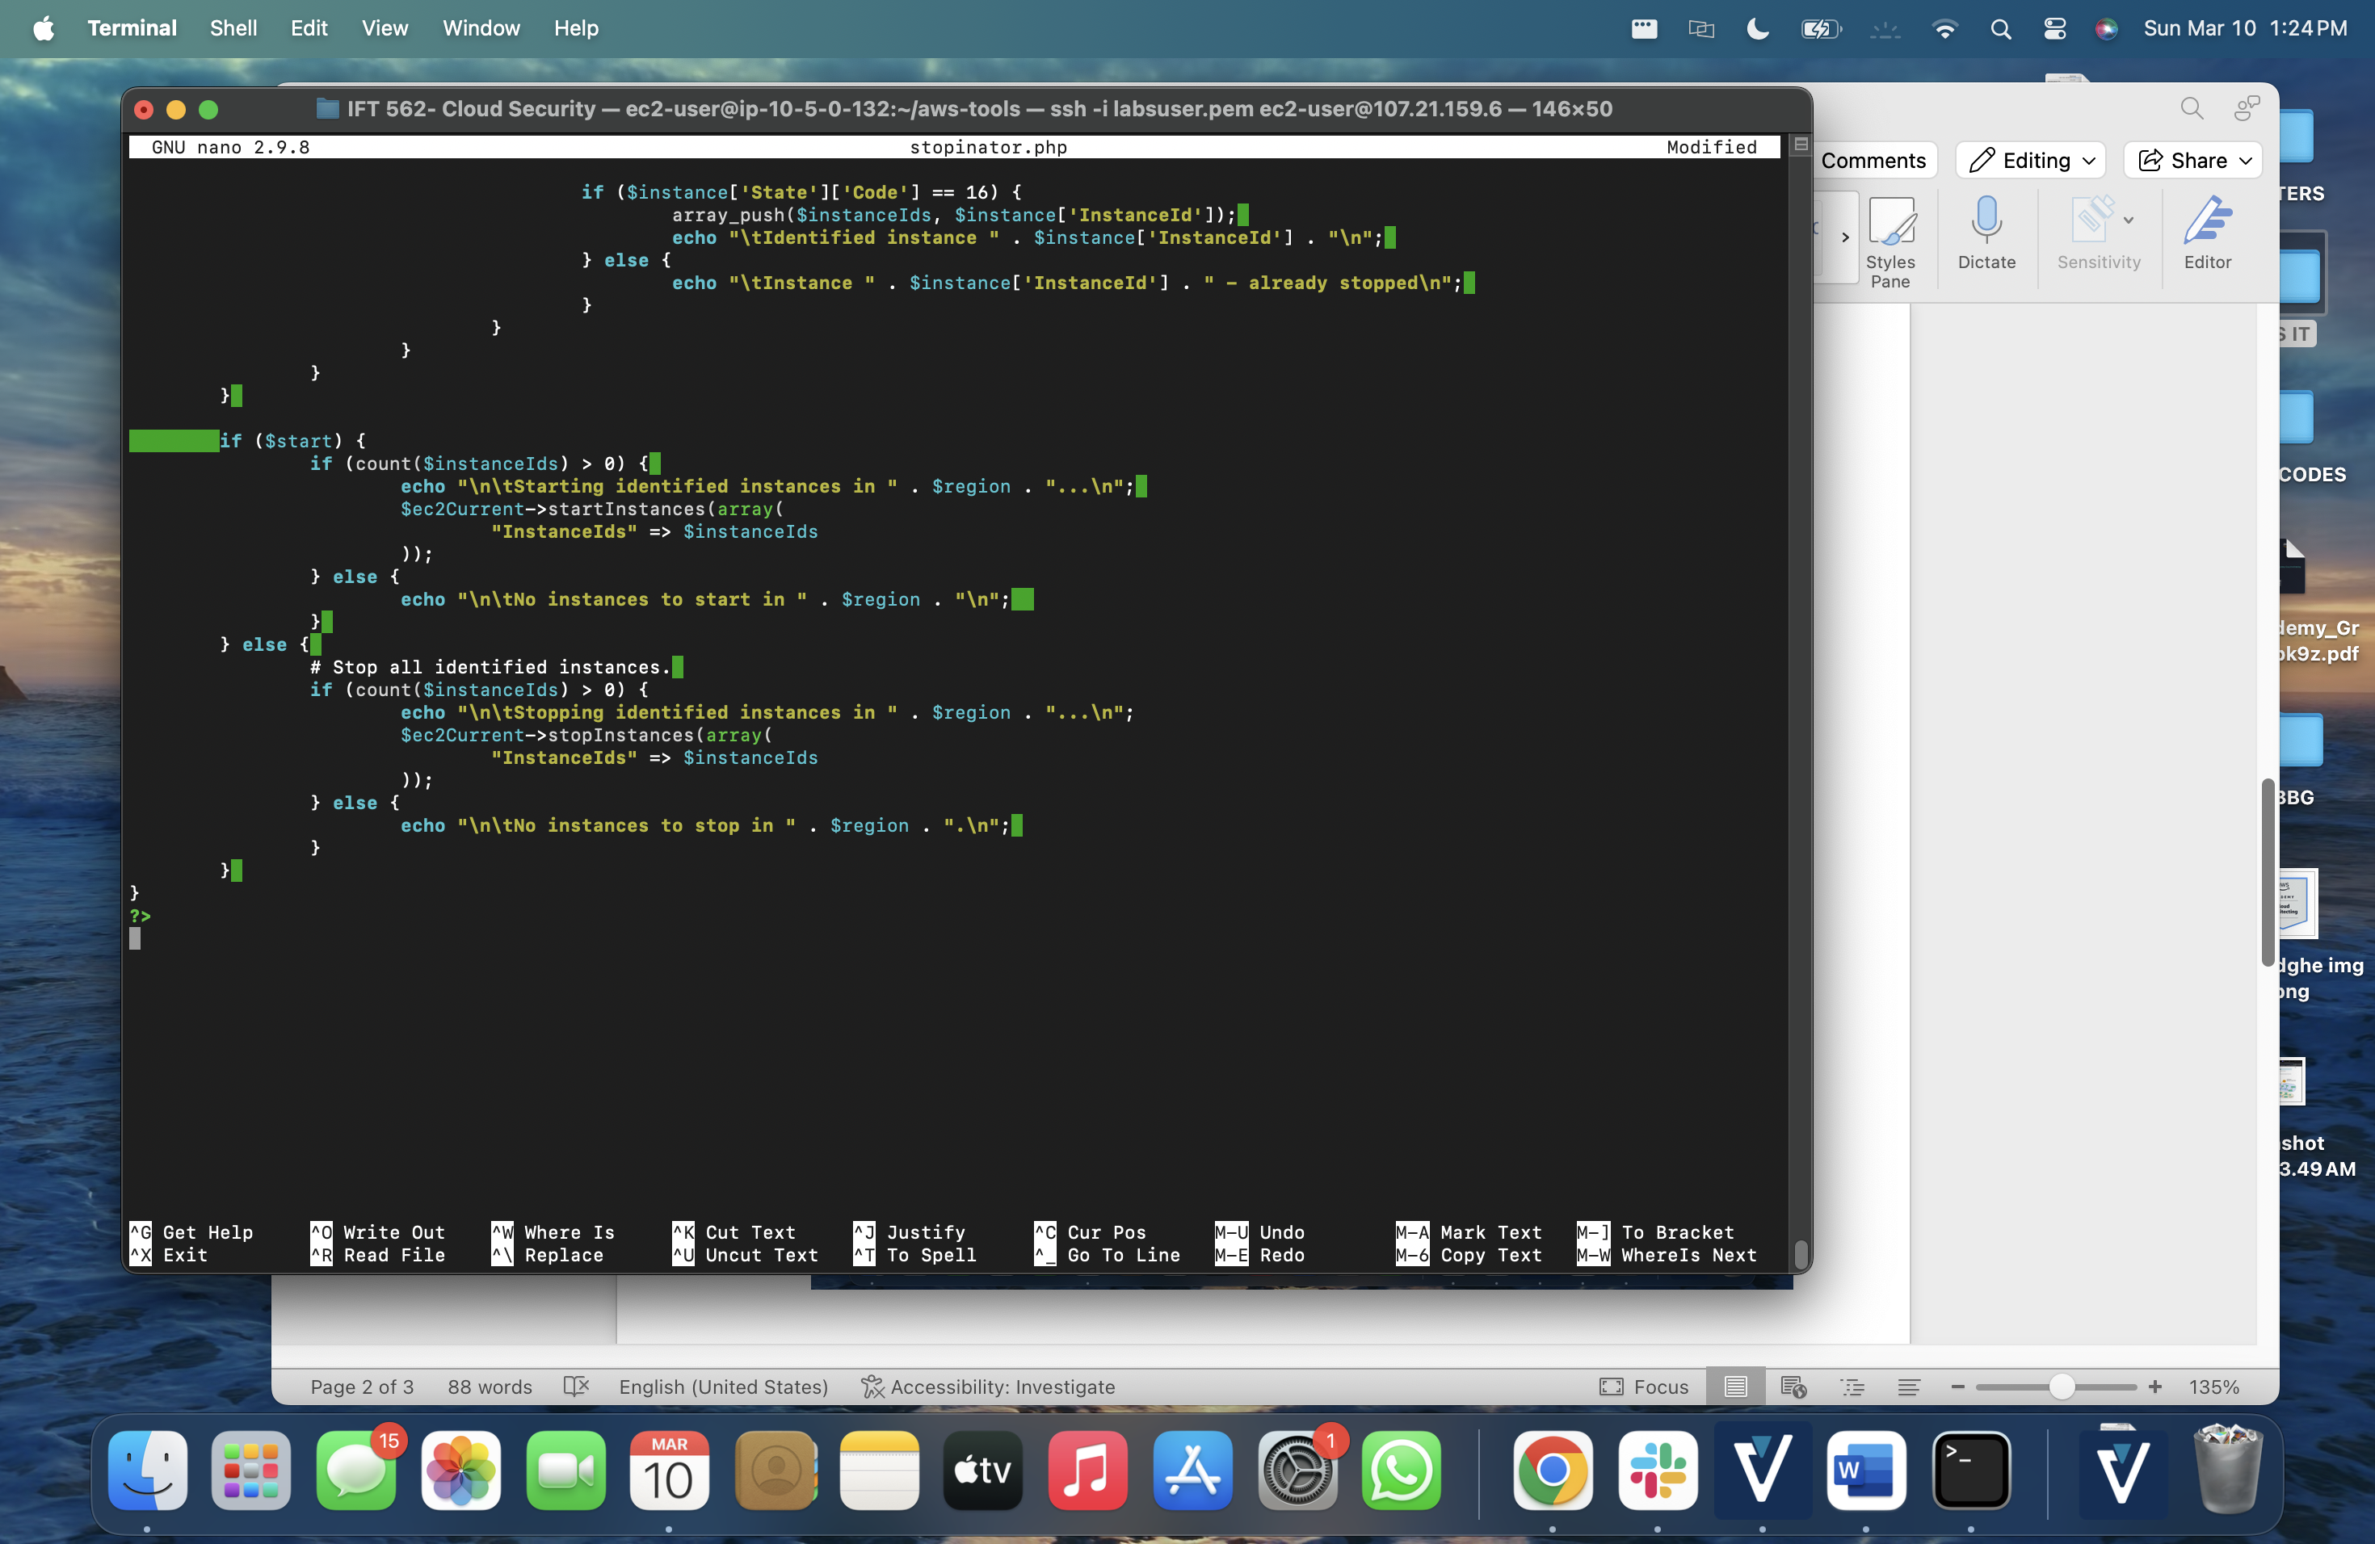

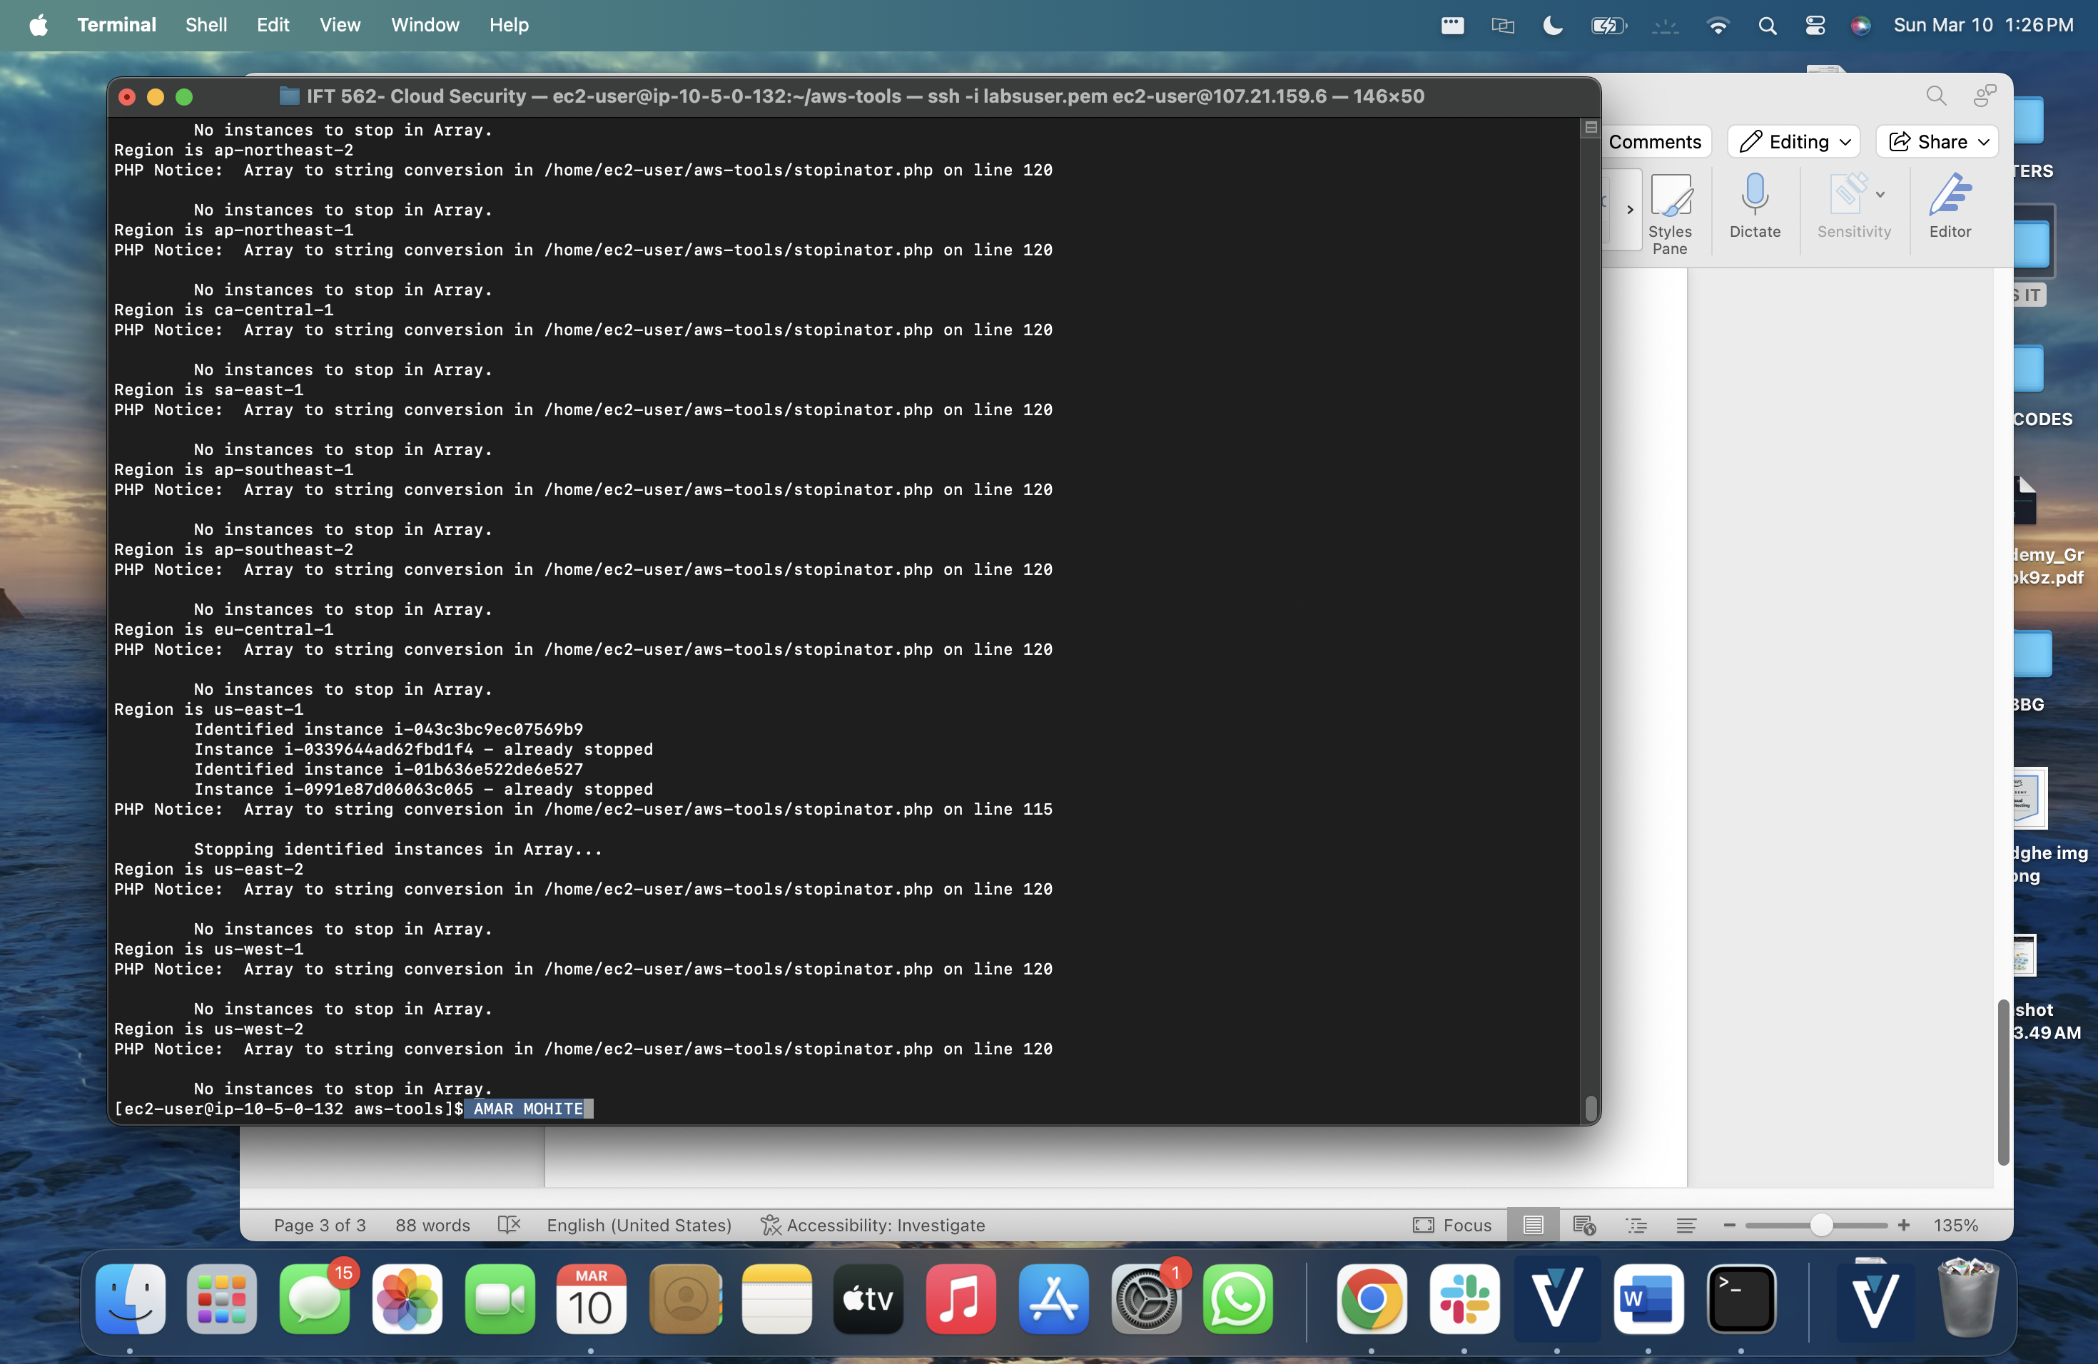

At the end of Task 3.1, after running the terminate-instances script enter your full name in the command prompt, and take a screenshot.

